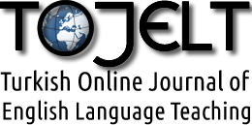

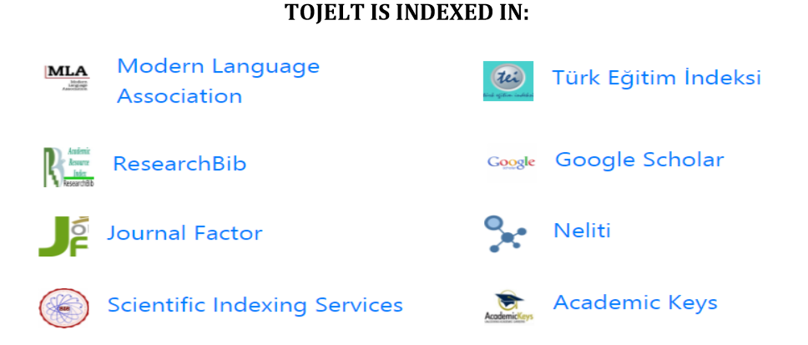

E-ISSN: 2458-9918

Contacts:
Home page: www.tojelt.com
E-mail: elt.tojelt@gmail.com
Owner of the Journal:
Assoc. Prof. Dr. Ahmet Selçuk AKDEMİR (Malatya Turgut Özal University)

All Rights Reserved. No part of this publication may be reproduced, stored or introduced into a retrieval system, or transmitted in any form, or by any means, electronic, mechanical, photocopying, recording, or otherwise, without the prior written permission of the TOJELT.
Copyright © 2022 – Turkish Online Journal of English Language Teaching (TOJELT)

Editor-in-Chief
Assoc. Prof. Dr. Ahmet Selçuk AKDEMİR – Malatya Turgut Özal University / Turkey
Assistant Editor
Berk Ilhan – Alanya Alaaddin Keykubat University / Turkey
Editorial & Advisory Board Members
Dr. Ali Fuad Selvi - Middle East Technical University / TRNC (Cyprus)
Dr. Çiler Hatipoğlu - Middle East Technical University / Turkey
Dr. Devo Y. Devrim- University of New England / Australia
Dr. Enrique Alejandro Basabes - Universidad Nacional de La Pampa Santa Rosa / Argentina
Dr. Gayane Hovhannisyan - Yerevan State Linguistic University / Armenia
Dr. Georgeta Rata - Banatuli University of Timişoara / Romania
Dr. Hasnaa Sary Helwaa - Benha University / Egypt
Dr. Inna Vladimirovna Pevneva - Kemerovo State University / Russian Federation
Dr. Jean-Marc Dewaele - University of London / England
Dr. Kyung Sook Cho - Busan National University of Education / South Korea
Dr. Maya Khemlani David - University of Malaya / Malaysia
Dr. Maya Sugita McEown - Waseda University / Japan
Dr. Michał B. Paradowski - University of Warsaw / Poland
Dr. Michael W. Purdy - Union University / USA
Dr. Osamu Takeuchi - Kansai University, Osaka / Japan
Dr. Paul Kei Matsuda - Arizona State University / USA
Dr. Rebecca L. Oxford - University of Alabama at Birmingham / USA
Dr. Richard McGarry - Appalachian State University Boone, North Carolina / USA
Dr. Stephen Krashen - University of Southern California / USA
Dr. Yilin Sun - South Seattle College / USA

TOJELT, Vol: 7 Issue: 2 Year: 2022

CONTENTS Page
Editorial ı
Articles
Unraveling the Linguistic Odyssey: An Investigation into the Intricate Nature of Language Development and Social Communication Skills in Autism Spectrum Disorders within the Context of Developmental Linguistics
Sinan Özyurt 58-96
Cross-subject grammar transferability to writing ability: A rhetoric-based grammar approach to improving writing skills
Kyung Sook Cho 97-108

Editorial Message
Dear Colleagues,
New issue of Turkish Online Journal of English Language Teaching (TOJELT) is online now with a rich academic content. We sincerely thank all board members and the referees for their efforts in the publication process of the issue.
With regards,
Dr. Ahmet Selçuk AKDEMİR
Editor

